C20424096 - Seán Breen / C20432034 - Keith Gore

**Logical Model**

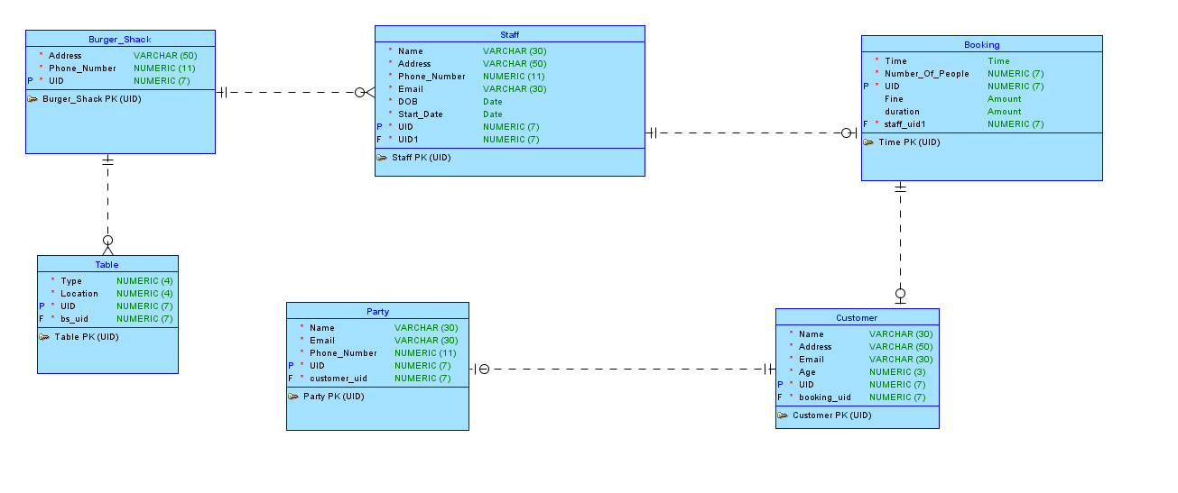

**Relational Model**

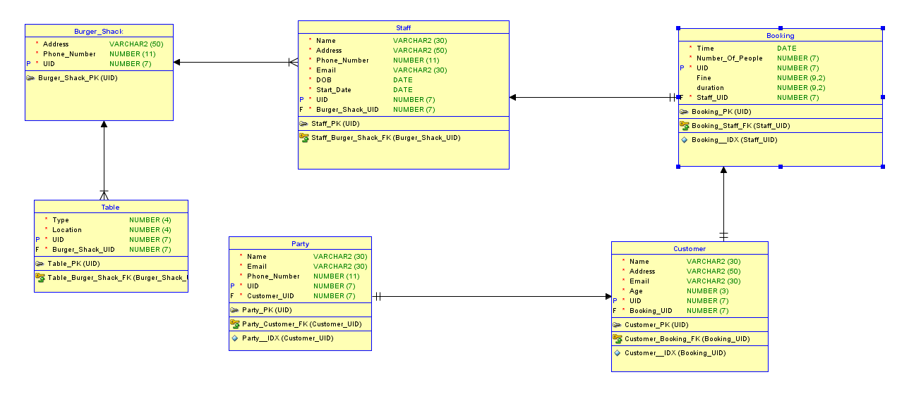

**Entities and Attributes**

Burger_Shack: Address, Phone Number, ID

Customer: Name, Address, Email, Age, ID

Booking: Time Number People (CONST: - > Max 6), ID, fine, staff_uid, duration

Table: Type (CONST - > 2, 4, 6, 8), Location (BOOL - > Window / Interior), ID, bs_uid

Party: Name, Email, Phone Number } - > *Excluding main cust* , ID, customer id

Staff: Name, Address, Phone Number, Email (CONST - > “@BurgerShack.com”), DOB, Start Date, ID } - > *Staff Member & Manager ,* bs uid

**Datatypes**

Burger_Shack: Address Varchar (50), Phone Number Numeric(11), ID Numeric(7)

Customer: Name Varchar (30), Address Varchar (50), Email Varchar (30), Age Numeric(3), ID Numeric(7)

Booking: Time time , Number_People Numeric(2), ID Numeric(7)

Table: Type Numeric(4), Location Numeric(4), ID Numeric(7)

Party: Name Varchar (30), Email Varchar (30), Phone Number Numeric(11), ID Numeric(7)

Staff: Name, Address Varchar (50), Phone Number, Email Varchar (30) , DOB Date, Start Date Date, ID Numeric(7)

**Domain Definitions:**

| **Name** | **Datatype** | **Size** |
| --- | --- | --- |
| ID | Numeric | Precision 7 |
| Address | Varchar | Size 50 |
| Phone Number | Numeric | Precision 11 |
| Name | Varchar | Size 30 |
| Email | Varchar | Size 30 |
| Age | Numeric | Precision 3 |
| Number_People | Numeric | Precision 2 |
| Type | Numeric | Precision 4 |
| Location | Numeric | Precision 4 |

**Foreign Keys:**

***--Foreign key defenitions***

**ALTER TABLE booking**

**ADD CONSTRAINT booking_staff_fk FOREIGN KEY ( staff_uid )**

**REFERENCES staff ( "UID" );**

**ALTER TABLE customer**

**ADD CONSTRAINT customer_booking_fk FOREIGN KEY ( booking_uid )**

**REFERENCES booking ( "UID" );**

**ALTER TABLE party**

**ADD CONSTRAINT party_customer_fk FOREIGN KEY ( customer_uid )**

**REFERENCES customer ( "UID" );**

**ALTER TABLE staff**

**ADD CONSTRAINT staff_burger_shack_fk FOREIGN KEY ( burger_shack_uid )**

**REFERENCES burger_shack ( "UID" );**

**ALTER TABLE "Table"**

**ADD CONSTRAINT table_burger_shack_fk FOREIGN KEY ( burger_shack_uid )**

**REFERENCES burger_shack ( "UID" );**

**Constraints:**

We chose the UID as the primary key as it is unique to each table.



This code adds a primary key in the booking table as UID



This code adds a primary key in the burger_shack table as UID



These constraints on the customer table make sure that the customer is 18 or older and that they have a valid email address.



This code adds a primary key in the customer table as UID



This code adds a primary key in the party table as UID



This constraint will make sure that the waiters email will end in @bugershack.com



This code adds a primary key in the staff table as UID



This code adds a primary key in the ‘Table’ table as UID

**ALTER TABLE booking**

**ADD CONSTRAINT booking_staff_fk FOREIGN KEY ( staff_uid )**

**REFERENCES staff ( "UID" );**

This constraint will add the staff_uid as foreign key in the booking table

**ALTER TABLE customer**

**ADD CONSTRAINT customer_booking_fk FOREIGN KEY ( booking_uid )**

**REFERENCES booking ( "UID" );**

This constraint will add the booking_uid as the Foreign key in the customers table

**ALTER TABLE party**

**ADD CONSTRAINT party_customer_fk FOREIGN KEY ( customer_uid )**

**REFERENCES customer ( "UID" );**

This constraint will add the customer_uid as the Foreign key in the party table

**ALTER TABLE staff**

**ADD CONSTRAINT staff_burger_shack_fk FOREIGN KEY ( burger_shack_uid )**

**REFERENCES burger_shack ( "UID" );**

This constraint will add the buger_shack_uid as the Foreign key in the staff table

**ALTER TABLE "Table"**

**ADD CONSTRAINT table_burger_shack_fk FOREIGN KEY ( burger_shack_uid )**

**REFERENCES burger_shack ( "UID" );**

This constraint will add the buger_shack_uid as the Foreign key in the ‘Table’ table

**Use of Delete/Update**

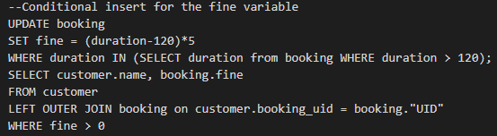

**Use of selection function.**

**Use of Inner Join Using Group**

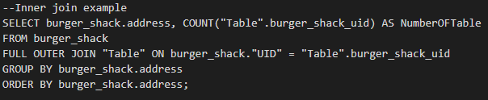

**Use of left outer join**

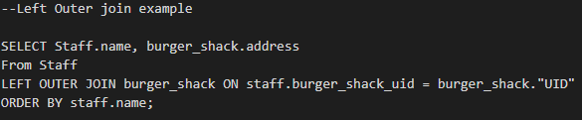

**Use of right outer join**

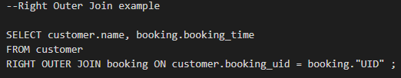

**Use of union**

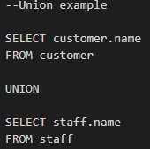

**Use of intersect**

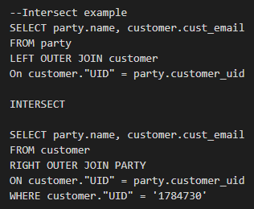

**Use of view**

